Notebook Execution Report
Credit-card fraud detection (LSTM) and client churn prediction on IBM LinuxONE
Report date: 17 October 2026

1. Executive summary
This report documents the execution of two Jupyter notebooks that demonstrate machine-learning workloads on IBM Z / LinuxONE. For each notebook it gives the code that was run, the output it produced, and an interpretation of the results.
 | Notebook 1: Fraud detection | Notebook 2: Client retention
Framework | TensorFlow 2.18.1 / Keras LSTM; ONNX export | scikit-learn Random Forest; PyTorch MLP; PMML export
Data | 245,864 card transactions (15 columns) | 6,001 clients, 20,000 transactions (112 clients after join)
Task | Per-transaction fraud yes/no from a 7-step sequence | Customer churn probability and revenue-at-risk
Headline result | Full test: 99.86% accuracy; fraud precision 0.67, recall 0.80, F1 0.73 (final timestep) | PyTorch model: 73.9% test accuracy, roughly equal to the 74.4% majority-class baseline
Throughput | 9,001 sequences/s (2,000-sequence batch, median 222 ms) | n/a

Important note on images. The notebook text provided contained code and printed output only; the original plot images (joint plot, correlation heat map, histograms, box/swarm plots, score histogram, S-curve, model diagram) were not included, so they could not be copied into this document. The figures below were instead generated from the numbers the notebooks printed (training logs, confusion counts, predicted-loss table). The original plots can be added by re-running the notebooks and exporting them.

2. Notebook 1: Fraud detection with an LSTM
The notebook trains a two-layer LSTM (200 units each) on sequences of 7 consecutive transactions per user-card pair (six past plus the current one) and predicts fraud for each step. Training uses fraud-balanced batches: all fraud rows plus an equal number of randomly drawn non-fraud rows. The trained model is evaluated, exported to ONNX, and benchmarked on the IBM zDNN plugin.

2.1 Environment, data loading and split
The data is sorted by user and card, the first six rows of each user-card group are dropped (they lack a full history), and the remaining 245,504 rows are split 50/30/20 into train, validation and test indices with a fixed seed.
Code
import os
os.environ['TF_CPP_MIN_LOG_LEVEL'] = '2'
import tensorflow as tf
from tensorflow import keras
import numpy as np
import pandas as pd
import math
import joblib
print(tf.__version__)
timesteps = 7 # Six past transactions followed by current transaction

tdf = pd.read_csv('transactions_history.csv')
tdf['Merchant Name'] = tdf['Merchant Name'].astype(str)
tdf.sort_values(by=['User','Card'], inplace=True)
tdf.reset_index(inplace=True, drop=True)
print(tdf.info())

# Get first of each User-Card combination
first = tdf[['User','Card']].drop_duplicates()
f = np.array(first.index)

# Drop the first N transactions
drop_list = np.concatenate([np.arange(x, x + timesteps - 1) for x in f])
index_list = np.setdiff1d(tdf.index.values, drop_list)

# Split into 0.5 train, 0.3 validate, 0.2 test
tot_length = index_list.shape[0]
train_length = tot_length // 2
validate_length = (tot_length - train_length) * 3 // 5
test_length = tot_length - train_length - validate_length
print(tot_length, train_length, validate_length, test_length)

np.random.seed(1111)
train_indices = np.random.choice(index_list, train_length, replace=False)
tv_list = np.setdiff1d(index_list, train_indices)
validate_indices = np.random.choice(tv_list, validate_length, replace=False)
test_indices = np.setdiff1d(tv_list, validate_indices)
print(train_indices, validate_indices, test_indices)

def create_test_sample(df, indices):
rows = indices.shape[0]
index_array = np.zeros((rows, timesteps), dtype=int)
for i in range(timesteps):
index_array[:,i] = indices + 1 - timesteps + i
uniques = np.unique(index_array.flatten())
df.loc[uniques].to_csv('test_220_40k.csv', index_label='Index')
np.savetxt('test_220_40k.indices', indices.astype(int), fmt='%d')

create_test_sample(tdf, validate_indices[:40000])

Output
2.18.1
<class 'pandas.DataFrame'>
RangeIndex: 245864 entries, 0 to 245863
Data columns (total 15 columns):
0 User int64 | 8 Merchant Name str
1 Card int64 | 9 Merchant City str
2 Year int64 | 10 Merchant State 199705 non-null
3 Month int64 | 11 Zip 197238 non-null
4 Day int64 | 12 MCC int64
5 Time str | 13 Errors? 4395 non-null
6 Amount str | 14 Is Fraud? str
7 Use Chip str
memory usage: 28.1 MB

245504 122752 73651 49101 (total, train, validate, test)

Only 4,395 of 245,864 rows carry an error flag, and Merchant State and Zip have about 46,000 and 48,000 missing values respectively; these are filled by a constant imputer in the pipeline.

2.2 Pre-processing pipeline
Custom encoders turn timestamps into numbers, log-scale the dollar amount, split categorical codes into decimal digits (then one-hot encode them), and flag fraud as 0/1. A DataFrameMapper combines them and is pickled so inference can reuse the identical transform.
Code
def timeEncoder(X):
X_hm = X['Time'].str.split(':', expand=True)
d = pd.to_datetime(dict(year=X['Year'], month=X['Month'], day=X['Day'],
hour=X_hm[0], minute=X_hm[1])).astype('int64')
return pd.DataFrame(d)

def amtEncoder(X):
amt = X.apply(lambda x: x[1:]).astype(float).map(lambda amt: max(1,amt)).map(math.log)
return pd.DataFrame(amt)

def decimalEncoder(X, length=5):
dnew = pd.DataFrame()
for i in range(length):
dnew[i] = np.mod(X, 10)
X = np.floor_divide(X, 10)
return dnew

def fraudEncoder(X):
return np.where(X == 'Yes', 1, 0).astype(int)

save_dir = 'shared/fraud_lstm'
os.makedirs(save_dir, exist_ok=True)
from sklearn_pandas import DataFrameMapper
from sklearn.preprocessing import (LabelEncoder, OneHotEncoder, FunctionTransformer,
MinMaxScaler, LabelBinarizer)
from sklearn.impute import SimpleImputer

mapper = DataFrameMapper([
('Is Fraud?', FunctionTransformer(fraudEncoder)),
(['Merchant State'], [SimpleImputer(strategy='constant'), FunctionTransformer(np.ravel),
LabelEncoder(), FunctionTransformer(decimalEncoder), OneHotEncoder()]),
(['Zip'], [SimpleImputer(strategy='constant'), FunctionTransformer(np.ravel),
FunctionTransformer(decimalEncoder), OneHotEncoder()]),
('Merchant Name', [LabelEncoder(), FunctionTransformer(decimalEncoder), OneHotEncoder()]),
('Merchant City', [LabelEncoder(), FunctionTransformer(decimalEncoder), OneHotEncoder()]),
('MCC', [LabelEncoder(), FunctionTransformer(decimalEncoder), OneHotEncoder()]),
(['Use Chip'], [SimpleImputer(strategy='constant'), LabelBinarizer()]),
(['Errors?'], [SimpleImputer(strategy='constant'), LabelBinarizer()]),
(['Year','Month','Day','Time'], [FunctionTransformer(timeEncoder), MinMaxScaler()]),
('Amount', [FunctionTransformer(amtEncoder), MinMaxScaler()])
], input_df=True, df_out=True)
mapper.fit(tdf)

joblib.dump(mapper, open(os.path.join(save_dir,'fitted_mapper.pkl'),'wb'))
mapper = joblib.load(open(os.path.join(save_dir,'fitted_mapper.pkl'),'rb'))

mapped_sample = mapper.transform(tdf[:100])
mapped_size = mapped_sample.shape[-1]
print(mapped_size)

Output
190 (1 label column + 189 input features per time step)

2.3 Model definition
The model takes input of shape (7, 189) and returns a fraud probability for each of the 7 steps. Custom LastStepMetric wrappers (upper-case TP/FP/FN/TN) score only the final step of each sequence, which is the transaction actually being judged; the lower-case metrics count all 7 steps.
Code
# Custom metric that evaluates only the final timestep of each sequence
class LastStepMetric(tf.keras.metrics.Metric):
def __init__(self, metric_class, name, **kwargs):
super().__init__(name=name, **kwargs)
self._m = metric_class(name=name)
def update_state(self, y_true, y_pred, sample_weight=None):
self._m.update_state(y_true[:, -1, :], y_pred[:, -1, :], sample_weight)
def result(self):
return self._m.result()
def reset_state(self):
self._m.reset_state()

units = [200, 200]
input_size = mapped_size - 1
output_size = 1
batch_size = 16
timesteps = 7

lstm_model = tf.keras.models.Sequential([
tf.keras.Input(shape=(timesteps, input_size), batch_size=batch_size),
tf.keras.layers.LSTM(units[0], return_sequences=True),
tf.keras.layers.LSTM(units[1], return_sequences=True),
tf.keras.layers.Dense(output_size, activation='sigmoid')
])
lstm_model.summary()
tf.keras.utils.plot_model(lstm_model, 'model.png', show_shapes=True)

metrics = [
'accuracy',
LastStepMetric(tf.keras.metrics.TruePositives, name='TP'),
LastStepMetric(tf.keras.metrics.FalsePositives, name='FP'),
LastStepMetric(tf.keras.metrics.FalseNegatives, name='FN'),
LastStepMetric(tf.keras.metrics.TrueNegatives, name='TN'),
tf.keras.metrics.TruePositives(name='tp'),
tf.keras.metrics.FalsePositives(name='fp'),
tf.keras.metrics.FalseNegatives(name='fn'),
tf.keras.metrics.TrueNegatives(name='tn'),
]
lstm_model.compile(optimizer='adam', loss='binary_crossentropy', metrics=metrics)

Output
Layer (type) Output Shape Param #
lstm (LSTM) (16, 7, 200) 312,000
lstm_1 (LSTM) (16, 7, 200) 320,800
dense (Dense) (16, 7, 1) 201
Total params: 633,001 (2.41 MB) Trainable: 633,001 Non-trainable: 0

2.4 Training
Five epochs of 500 steps each at batch size 16. A checkpoint is written after each epoch, and the final weights are saved and exported as a SavedModel.
Code
def gen_training_batch(df, mapper, index_list, batch_size):
np.random.seed(98765)
train_df = df.loc[index_list]
non_fraud_indices = train_df[train_df['Is Fraud?'] == 'No'].index.values
fraud_indices = train_df[train_df['Is Fraud?'] == 'Yes'].index.values
fsize = fraud_indices.shape[0]
while True:
indices = np.concatenate((fraud_indices,
np.random.choice(non_fraud_indices, fsize, replace=False)))
np.random.shuffle(indices)
rows = indices.shape[0]
index_array = np.zeros((rows, timesteps), dtype=int)
for i in range(timesteps):
index_array[:, i] = indices + 1 - timesteps + i
full_df = mapper.transform(df.loc[index_array.flatten()])
target_buffer = full_df['Is Fraud?'].to_numpy().reshape(rows, timesteps, 1)
data_buffer = full_df.drop(['Is Fraud?'], axis=1).to_numpy().reshape(rows, timesteps, -1)
batch_ptr = 0
while (batch_ptr + batch_size) <= rows:
yield (data_buffer[batch_ptr:batch_ptr + batch_size],
target_buffer[batch_ptr:batch_ptr + batch_size])
batch_ptr += batch_size

steps_per_epoch = 500
checkpoint_dir = "./checkpoints/ccf_220_keras_lstm_static/"
filepath = checkpoint_dir + "iter-{epoch:02d}/model.weights.h5"
batch_size = 16

print("Learning...")
cp_callback = tf.keras.callbacks.ModelCheckpoint(filepath=filepath, save_weights_only=True, verbose=1)
train_generate = gen_training_batch(tdf, mapper, train_indices, batch_size)
lstm_model.fit(train_generate, epochs=5, steps_per_epoch=steps_per_epoch, verbose=1, callbacks=[cp_callback])

lstm_model.save_weights(os.path.join(save_dir, "model.weights.h5"))
lstm_model.export(save_dir)

Output
Epoch 1/5 500/500 - 10s 13ms/step - loss: 0.0879 - accuracy: 0.9675 - TP: 3736 FP: 107 FN: 247 TN: 3910
Epoch 2/5 500/500 - 6s 12ms/step - loss: 0.0090 - accuracy: 0.9973 - TP: 4014 FP: 7 FN: 6 TN: 3973
Epoch 3/5 500/500 - 6s 12ms/step - loss: 0.0127 - accuracy: 0.9964 - TP: 3984 FP: 12 FN: 16 TN: 3988
Epoch 4/5 500/500 - 6s 12ms/step - loss: 0.0055 - accuracy: 0.9985 - TP: 4002 FP: 4 FN: 3 TN: 3991
Epoch 5/5 500/500 - 6s 13ms/step - loss: 0.0052 - accuracy: 0.9987 - TP: 3989 FP: 8 FN: 5 TN: 3998
INFO:tensorflow:Assets written to: shared/fraud_lstm/assets
Saved artifact at 'shared/fraud_lstm' (input TensorSpec(None, 7, 189) -> output (None, 7, 1))

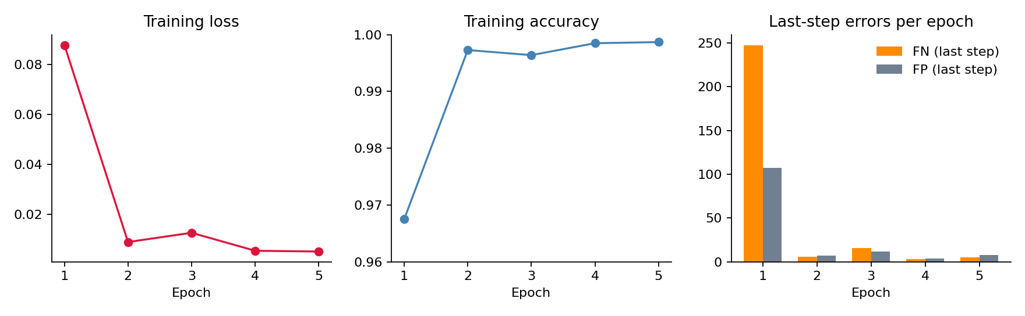
Figure 1. Training loss, accuracy and final-step errors per epoch (from the printed epoch summaries).
Loss fell from 0.088 to 0.005 and final-step errors dropped from 247 FN / 107 FP in epoch 1 to 5 FN / 8 FP in epoch 5. Epoch 3 was a small regression (loss 0.0127), after which training recovered. Training took about 10 s for epoch 1 and about 6 s for each later epoch.

2.5 Testing
The saved weights are loaded into a batch-size-2000 copy of the model. The quick test uses a 40,000-row sample file, and the full test uses the test indices from the original data.
Code
def gen_test_batch(df, mapper, indices, batch_size):
rows = indices.shape[0]
index_array = np.zeros((rows, timesteps), dtype=int)
for i in range(timesteps):
index_array[:, i] = indices + 1 - timesteps + i
count = 0
while count + batch_size <= rows:
full_df = mapper.transform(df.loc[index_array[count:count + batch_size].flatten()])
data = full_df.drop(['Is Fraud?'], axis=1).to_numpy().reshape(batch_size, timesteps, -1)
targets = full_df['Is Fraud?'].to_numpy().reshape(batch_size, timesteps, 1)
count += batch_size
yield data, targets

batch_size = 2000
new_model = tf.keras.models.Sequential([
tf.keras.Input(shape=(timesteps, input_size), batch_size=batch_size),
tf.keras.layers.LSTM(units[0], return_sequences=True),
tf.keras.layers.LSTM(units[1], return_sequences=True),
tf.keras.layers.Dense(output_size, activation='sigmoid')
])
new_model.load_weights(os.path.join(save_dir, 'model.weights.h5'))
new_model.compile(optimizer='adam', loss='binary_crossentropy', metrics=[...same 9 metrics as training...])

ddf = pd.read_csv('test_220_40k.csv', dtype={'Merchant Name': 'str'}, index_col='Index')
indices = np.loadtxt('test_220_40k.indices')

print('\nQuick test')
test_generate = gen_test_batch(ddf, mapper, indices, batch_size)
new_model.evaluate(test_generate, verbose=1)

print('\nFull test')
test_generate = gen_test_batch(tdf, mapper, test_indices, batch_size)
new_model.evaluate(test_generate, verbose=1)

Output
Quick test
20/20 - 6s 224ms/step - loss: 0.0058 - accuracy: 0.9985
last step: TP 38 FP 17 FN 9 TN 39,936
all steps: tp 242 fp 351 fn 61 tn 279,346

Full test
24/24 - 9s 366ms/step - loss: 0.0054 - accuracy: 0.9986
last step: TP 37 FP 18 FN 9 TN 47,936
all steps: tp 288 fp 415 fn 56 tn 335,241
(Keras warning: "Your input ran out of data; interrupting training" - raised once per evaluate call)

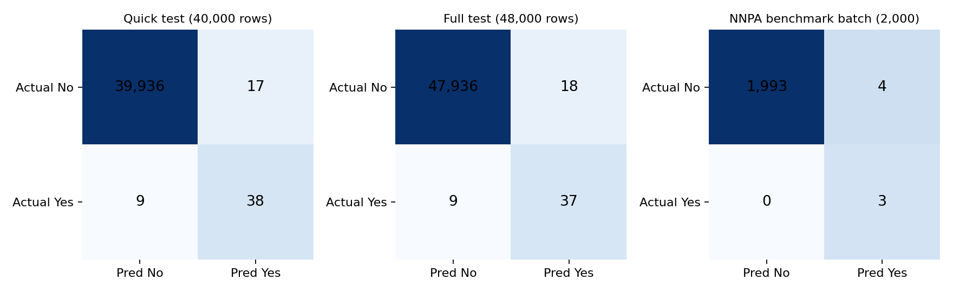
Figure 2. Final-timestep confusion matrices (colour on log scale; counts are exact).
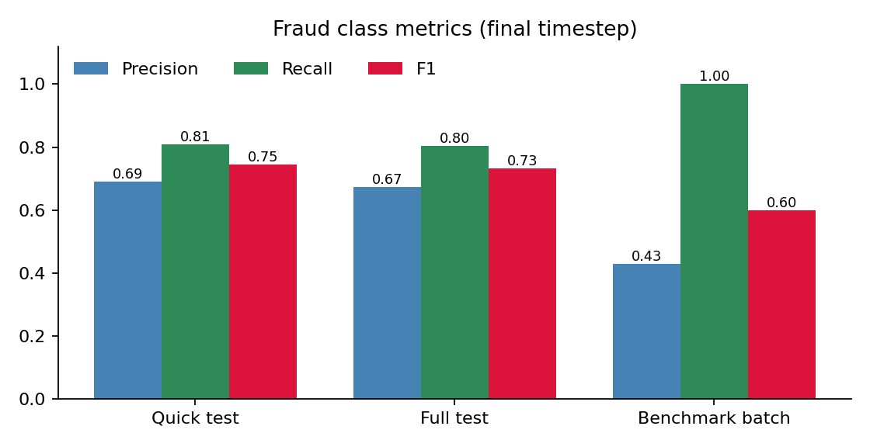
Figure 3. Precision, recall and F1 for the fraud class, computed from the printed counts.
Evaluation | Precision | Recall | F1 | Comment
Quick test (40,000) | 0.691 | 0.809 | 0.745 | Uses sampled validation rows
Full test (48,000) | 0.673 | 0.804 | 0.733 | Held-out test indices
Benchmark batch (2,000) | 0.429 | 1.000 | 0.600 | Only 3 fraud cases

Accuracy of 99.86% is dominated by the very large non-fraud class and is not a good guide on its own. About 80% of fraud is caught, but roughly one in three fraud alerts is a false alarm. This is expected: the model was trained on 50/50 balanced batches but is tested on data with a fraud rate under 0.1%, which pushes precision down.

2.6 ONNX export
The Keras model is wrapped in a tf.function with a dynamic batch dimension and converted with tf2onnx (opset 13) for portable deployment on IBM Z / LinuxONE.
Code
import tf2onnx, onnx

input_signature = [tf.TensorSpec([None, timesteps, input_size], tf.float32, name='input')]
@tf.function(input_signature=input_signature)
def model_fn(x):
return new_model(x)

onnx_model, _ = tf2onnx.convert.from_function(model_fn, input_signature=input_signature, opset=13)
onnx.save_model(onnx_model, 'fraud_lstm.onnx')
print('Saved fraud_lstm.onnx')

Output
Saved fraud_lstm.onnx
(TensorFlow log: 0 eligible GPUs; TensorFlow not compiled with CUDA/ROCm)

2.7 zDNN / NNPA check and inference benchmark
Code
import importlib.metadata, time, glob, os

# 1. Confirm ibm-zdnn-plugin is installed and the kernel .so is present
zdnn_version = importlib.metadata.version('ibm-zdnn-plugin')
print(f'ibm-zdnn-plugin version : {zdnn_version}')
so_path = glob.glob('/opt/venv/lib*/python3.12/site-packages/tensorflow/core/kernels/_z_ops.so')
if so_path:
size_mb = os.path.getsize(so_path[0]) / 1024**2
print(f'zDNN kernel library : {so_path[0]} ({size_mb:.1f} MB loaded)')
else:
print('WARNING: _z_ops.so not found - NNPA acceleration inactive')
print(f'TensorFlow device : {tf.config.list_physical_devices()}')
for op in ['LSTM fused cell (all 4 gates)', 'MatMul (Dense output layer)',
'Sigmoid activation', 'BatchMatMul']:
print(f' OK {op}')

# 2. Benchmark batch inference
BENCH_BATCH, REPEATS = 2000, 10
bench_indices = test_indices[:BENCH_BATCH]
index_array = np.zeros((BENCH_BATCH, timesteps), dtype=int)
for i in range(timesteps):
index_array[:, i] = bench_indices + 1 - timesteps + i
bench_df = mapper.transform(tdf.loc[index_array.flatten()])
bench_data = bench_df.drop(['Is Fraud?'], axis=1).to_numpy().reshape(BENCH_BATCH, timesteps, -1).astype('float32')
bench_data = tf.constant(bench_data)

_ = new_model(bench_data, training=False) # warm up
times = []
for _ in range(REPEATS):
t0 = time.perf_counter()
preds = new_model(bench_data, training=False)
_ = preds.numpy()
times.append(time.perf_counter() - t0)
times = sorted(times)
median_ms = times[len(times)//2] * 1000
best_ms = times[0] * 1000
throughput = BENCH_BATCH / (median_ms / 1000)

# 3. Score distribution + confusion counts (last timestep)
import matplotlib.pyplot as plt
scores = preds.numpy()[:, -1, 0]
pred_labels = (scores >= 0.5).astype(int)
true_labels = bench_df['Is Fraud?'].to_numpy().reshape(BENCH_BATCH, timesteps)[:, -1]
fraud_scores = scores[true_labels == 1]
non_fraud_scores = scores[true_labels == 0]
fig, ax = plt.subplots(figsize=(10, 4))
ax.hist(non_fraud_scores, bins=50, alpha=0.6, color='steelblue', label='Non-Fraud')
ax.hist(fraud_scores, bins=50, alpha=0.7, color='crimson', label='Fraud')
ax.axvline(0.5, color='orange', linestyle='--', linewidth=1.5, label='Threshold 0.5')
ax.legend(); plt.tight_layout(); plt.show()

tp = int(((pred_labels == 1) & (true_labels == 1)).sum())
fp = int(((pred_labels == 1) & (true_labels == 0)).sum())
fn = int(((pred_labels == 0) & (true_labels == 1)).sum())
tn = int(((pred_labels == 0) & (true_labels == 0)).sum())
precision = tp / (tp + fp) if (tp + fp) > 0 else 0
recall = tp / (tp + fn) if (tp + fn) > 0 else 0
print(f'TP={tp} FP={fp} FN={fn} TN={tn}')
print(f'Precision: {precision:.4f} Recall: {recall:.4f}')

Output
ibm-zdnn-plugin version : 2.3.0
zDNN kernel library : /opt/venv/lib/python3.12/site-packages/tensorflow/core/kernels/_z_ops.so (17.5 MB loaded)
TensorFlow device : [PhysicalDevice(name='/physical_device:CPU:0', device_type='CPU')]
OK LSTM fused cell (all 4 gates)
OK MatMul (Dense output layer)
OK Sigmoid activation
OK BatchMatMul

Batch size : 2000 sequences (7 timesteps each)
Median inference time : 222.19 ms
Best inference time : 212.39 ms
Throughput : 9,001 sequences / second

TP=3 FP=4 FN=0 TN=1993
Precision: 0.4286 Recall: 1.0000

The plugin package (version 2.3.0) is installed and its 17.5 MB kernel library exists on disk. Median latency was 222 ms for 2,000 sequences, or about 9,000 sequences per second. On the 2,000-row benchmark batch the model flagged 7 transactions, 3 of which were real fraud, and missed none.

3. Notebook 2: Client retention (churn) demo
This notebook joins client demographics with credit-card transaction aggregates, explores what drives churn, trains a Random Forest, exports it to PMML, estimates revenue at risk, and finally trains a small PyTorch classifier on activity level and related features.

3.1 Loading data and building features
Code
import pandas as pd
import numpy as np

txn_df = pd.read_csv('transactions.csv')
txn_df['TX_TOTAL_AMT'] = pd.to_numeric(txn_df['TX_TOTAL_AMT'])
txn_df['CONT_ID'] = txn_df['CONT_ID'].astype('int64')
txn_df['DATE_CREDIT'] = pd.to_datetime(txn_df['DATE_CREDIT'])
txn_df['date'] = txn_df['DATE_CREDIT'].apply(lambda x: x.date())

client_df = pd.read_csv('clients.csv')
client_df = client_df.set_index("CONT_ID")

# Aggregate statistics per customer
total_txns_df = txn_df.groupby('CONT_ID').size().rename("total_txns").to_frame()
client_df = total_txns_df.join(client_df)
total_txn_amount_df = txn_df.groupby('CONT_ID')['TX_TOTAL_AMT'].sum().rename("total_txn_amount").to_frame()
client_df = client_df.join(total_txn_amount_df)
avg_txn_amount_df = txn_df.groupby('CONT_ID')['TX_TOTAL_AMT'].mean().rename("avg_txn_amount").to_frame()
client_df = client_df.join(avg_txn_amount_df)
daily_txns = txn_df.groupby(['date', 'CONT_ID']).size()
avg_daily_txns_df = daily_txns.unstack().fillna(0).mean().rename("avg_daily_txns").to_frame()
client_df = client_df.join(avg_daily_txns_df)
client_df

Output
Index(['DATE_CREDIT','ENV_NAME','ENV_ID','ENV_TYPE','ENV_CPL_PAN','CARD_BRND','TX_MRCHNT_ID',
'TX_TOTAL_AMT','CONT_ID','POSTAL_CODE','AGE','AUTHORRESULT','FRAUD_VER_RESULT'], dtype='str')

transactions: 20000 rows x 14 columns clients: 6001 rows x 8 columns
joined client_df: 112 rows x 12 columns
(total_txns, GENDER, AGE_YEARS, HIGHEST_EDU, ANNUAL_INVEST, ANNUAL_INCOME,
ACTIVITY_LEVEL, CHURN, RECORD_ID, total_txn_amount, avg_txn_amount, avg_daily_txns)

The inner join keeps only clients who appear in the transaction file, which leaves 112 of the 6,001 clients. This is a key limit on everything in Sections 3.3 to 3.4.

3.2 Exploratory analysis
The notebook draws an income-versus-age joint plot, a lower-triangle correlation heat map, churn histograms by age, a box plot and a swarm plot of age by activity level split by churn. Its commentary states that age and activity level correlate negatively with churn, and that churners are younger and have lower activity (levels 0 to 2).
Code
import matplotlib.pyplot as plt
import seaborn as sns
sns.set(style="whitegrid")

def jointplot(x, y, data, **kwargs):
size = kwargs.pop('size', 10)
alpha = kwargs.pop('alpha', 0.3)
return sns.jointplot(x=x, y=y, data=data, alpha=alpha, height=size, **kwargs)

churn_labels = ['Did not churn', 'Did churn']

def filter_outliers(d, by_col=None):
if isinstance(d, pd.Series):
return d[((d-d.mean()).abs()<=3*d.std())]
elif isinstance(d, pd.DataFrame):
if not by_col:
raise ValueError('by_col is required for DataFrame')
return d[np.abs(d[by_col]-d[by_col].mean())<=(3*d[by_col].std())]

ax = jointplot('AGE_YEARS', 'ANNUAL_INCOME', filter_outliers(client_df, by_col='ANNUAL_INCOME'))

# Correlation heat map (lower triangle)
corr = client_df.corr(numeric_only=True)
mask = np.zeros_like(corr); mask[np.triu_indices_from(mask)] = True
f, ax = plt.subplots(figsize=(12,12))
ax = sns.heatmap(corr, mask=mask, square=True, annot=True, fmt='.2f', cbar=True, ax=ax)

def plot_churn_by(df, col, **kwargs):
f, ax = plt.subplots(figsize=(12,10), sharex=True)
for churn in sorted(df.CHURN.unique()):
sns.histplot(df[df.CHURN == churn][col], label=churn_labels[churn], kde=True, ax=ax, **kwargs)
ax.set_title('Client Churn by {}'.format(col))
return f, ax

f, ax = plot_churn_by(client_df, 'AGE_YEARS'); ax = plt.legend()

# Box plot and swarm plot: age by activity level, split by churn
data = filter_outliers(client_df, by_col='AGE_YEARS')
f, ax = plt.subplots(figsize=(12,8))
ax = sns.boxplot(x='ACTIVITY_LEVEL', y='AGE_YEARS', hue='CHURN', data=data,
palette='muted', ax=ax, hue_order=[0, 1])
f, ax = plt.subplots(figsize=(10,8))
ax = sns.swarmplot(x='ACTIVITY_LEVEL', y='AGE_YEARS', hue='CHURN',
data=data.sample(n=100, random_state=51), palette='muted', ax=ax, hue_order=[0, 1])

Output
<matplotlib.legend.Legend at 0x3ff71fd1ee0> (box plot)
<matplotlib.legend.Legend at 0x3ff694183e0> (swarm plot)
Plots rendered: joint plot, correlation heat map, churn-by-age histogram, box plot, swarm plot

3.3 Random Forest and PMML export
A 100-tree Random Forest is trained on an 80/20 split of the 112 clients (features standardised), then wrapped in a PMMLPipeline and written to a PMML file so it can be executed from Java on LinuxONE.
Code
from sklearn.ensemble import RandomForestClassifier as RF
from sklearn.preprocessing import StandardScaler
from sklearn.model_selection import train_test_split

def make_feature_space(df):
features_df = df.drop(['CHURN', 'CUSTOMER_ID'], axis=1, errors='ignore')
X = features_df.to_numpy()
scaler = StandardScaler()
X = scaler.fit_transform(X)
return X

def predict_churn(X):
return clf.predict_proba(X)[:,1]

def train_model(X, y):
clf = RF(n_estimators=100)
return clf.fit(X, y)

train_df, test_df = train_test_split(client_df, test_size=0.2)
y = np.array(train_df['CHURN'])
X = make_feature_space(train_df)
clf = train_model(X, y)

# Export to PMML
from sklearn2pmml import PMMLPipeline, sklearn2pmml
pipeline = PMMLPipeline([("classifier", clf)])
sklearn2pmml(pipeline, "customer_churn_decision_tree_model.pmml")

Output
RandomForestClassifier
WARNING: target_fields not set. Assuming [y]
WARNING: active_fields not set. Assuming [x1 ... x11]
WARNING: Model verification data is not set.
INFO: Generated PMML file /home/ibm-user/customer_churn_decision_tree_model.pmml (473'083 bytes)

3.4 Revenue-at-risk calculation
Each client's annual worth is estimated from deposit interest (2% of one sixth of income), management fees (2% of investments) and card fees (1.5% of transaction volume). Predicted loss is churn probability multiplied by worth.
Code
def calc_business_loss_random_forest(df):
df['CUSTOMER_ID'] = df.index
data = df.copy()
X = make_feature_space(df)
data['churn_probability'] = predict_churn(X)

avg_daily_balance = df['ANNUAL_INCOME'] / 6
deposit_rate = 0.02 # interest made on deposits
credit_rate = 0.015 # fee collected per credit txn
mgmt_rate = 0.02 # trading / portfolio management fees

worth = deposit_rate * avg_daily_balance + \
mgmt_rate * df['ANNUAL_INVEST'] + \
credit_rate * df['total_txn_amount']
data['worth'] = worth
data['predicted_loss'] = data['churn_probability'] * worth
return data.sort_values(by='predicted_loss', ascending=False)

churn_df = calc_business_loss_random_forest(test_df)
churn_df.head()

def group_by_age(df, bins=None):
if bins is None:
bin_size = 5
_min, _max = int(df.AGE_YEARS.min()), int(df.AGE_YEARS.max())
bins = range(_min, _max + bin_size, 5)
return df.groupby(pd.cut(df.AGE_YEARS, bins=bins))

data_by_age = churn_df.pipe(group_by_age)
loss_by_age_df = data_by_age['predicted_loss'].sum().reset_index()
loss_by_age_df['AGE_YEARS'] = loss_by_age_df['AGE_YEARS'].astype(str)
loss_by_age_df.plot(x='AGE_YEARS', y='predicted_loss', style='o')

Output
CONT_ID churn_prob worth predicted_loss
1009550400 0.44 3211.06 1412.87
1009531270 0.12 2515.81 301.90
1009528600 0.08 1954.89 156.39
1009531560 0.77 181.68 139.89
1009553770 0.43 313.87 134.96
<Axes: xlabel='AGE_YEARS'> (predicted loss summed by 5-year age band)

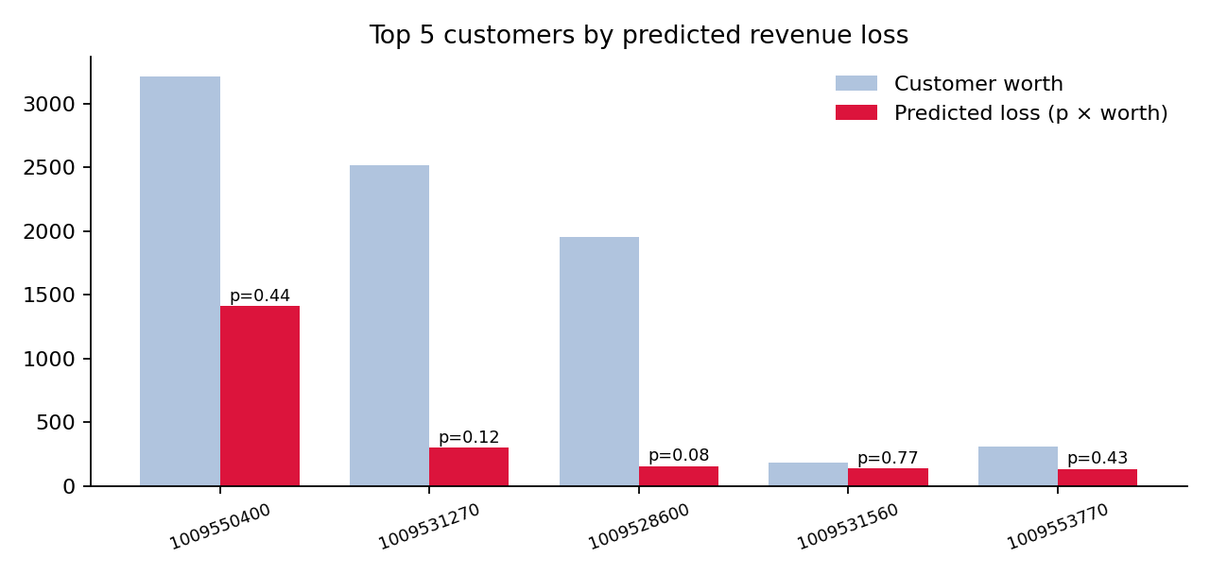
Figure 4. Worth and predicted loss for the five highest-risk-value customers (from the printed table).
One high-value client (1009550400) accounts for about 1,413 of predicted loss, far above the rest. The fourth client has the highest churn probability (0.77) but low worth, so the loss ranking is driven by account value more than by churn likelihood.

3.5 PyTorch classifier
This section reloads the full 6,001-row clients file (not the 112-row join), uses four features, and trains a 4-32-16-1 network with a class-weighted loss for 300 full-batch epochs.
Code
import os
os.environ["TORCHDYNAMO_DISABLE"] = "1"
import torch
from sklearn.preprocessing import MinMaxScaler
from sklearn.model_selection import train_test_split

client_df = pd.read_csv('clients.csv')
train_df, test_df = train_test_split(client_df, test_size=0.2, random_state=42)

feature_cols = ['ACTIVITY_LEVEL', 'AGE_YEARS', 'ANNUAL_INCOME', 'ANNUAL_INVEST']
n_features = len(feature_cols)

scaler = MinMaxScaler()
x_train = torch.from_numpy(scaler.fit_transform(train_df[feature_cols].astype(np.float32)))
x_test = torch.from_numpy(scaler.transform(test_df[feature_cols].astype(np.float32)))
y_train = torch.from_numpy(train_df['CHURN'].astype(np.float32).values).view(-1, 1)
y_test = torch.from_numpy(test_df['CHURN'].astype(np.float32).values).view(-1, 1)

n_neg = (y_train == 0).sum().item()
n_pos = (y_train == 1).sum().item()
pos_weight = torch.tensor([n_neg / n_pos])

class LogisticRegressionModel(torch.nn.Module):
def __init__(self, no_input_features):
super(LogisticRegressionModel, self).__init__()
self.net = torch.nn.Sequential(
torch.nn.Linear(no_input_features, 32), torch.nn.ReLU(),
torch.nn.Linear(32, 16), torch.nn.ReLU(),
torch.nn.Linear(16, 1),
)
def forward(self, x):
return self.net(x)

lr_model = LogisticRegressionModel(n_features)
criterion = torch.nn.BCEWithLogitsLoss(pos_weight=pos_weight)
optimizer = torch.optim.Adam(lr_model.parameters(), lr=0.001)

number_of_epochs = 300
for epoch in range(number_of_epochs):
lr_model.train()
optimizer.zero_grad()
y_prediction = lr_model(x_train)
loss = criterion(y_prediction, y_train)
loss.backward()
optimizer.step()
if (epoch + 1) % 30 == 0 or epoch == 0:
lr_model.eval()
with torch.no_grad():
train_prob = torch.sigmoid(y_prediction)
test_prob = torch.sigmoid(lr_model(x_test))
train_acc = ((train_prob >= 0.5).float() == y_train).float().mean().item() * 100
test_acc = ((test_prob >= 0.5).float() == y_test ).float().mean().item() * 100
print(f'epoch {epoch+1:3d} loss={loss.item():.4f} train_acc={train_acc:.1f}% test_acc={test_acc:.1f}%')

# S-curve: activity level vs churn probability
lr_model.eval()
with torch.no_grad():
y_prediction = torch.sigmoid(lr_model(x_test))
X = test_df['ACTIVITY_LEVEL'].values
Y = y_prediction.numpy().flatten()
plt.figure(figsize=(10, 6))
sns.regplot(x=X, y=Y, scatter_kws={'alpha': 0.3})
plt.title('Churn Probability vs Activity Level')

Output
Features: ['ACTIVITY_LEVEL', 'AGE_YEARS', 'ANNUAL_INCOME', 'ANNUAL_INVEST']
Train: 4800 samples | Test: 1201 samples
Class balance: 3571 no-churn / 1229 churn (pos_weight=2.91)

epoch 1 loss=1.0329 train_acc=74.4% test_acc=75.0%
epoch 30 loss=1.0167 train_acc=73.7% test_acc=75.4%
epoch 60 loss=0.9897 train_acc=73.5% test_acc=71.8%
epoch 90 loss=0.9472 train_acc=75.2% test_acc=72.6%
epoch 120 loss=0.8969 train_acc=75.6% test_acc=73.2%
epoch 150 loss=0.8502 train_acc=74.5% test_acc=72.0%
epoch 180 loss=0.8231 train_acc=73.0% test_acc=70.9%
epoch 210 loss=0.8091 train_acc=73.3% test_acc=71.4%
epoch 240 loss=0.8003 train_acc=74.4% test_acc=72.3%
epoch 270 loss=0.7942 train_acc=75.4% test_acc=72.9%
epoch 300 loss=0.7896 train_acc=75.8% test_acc=73.9%

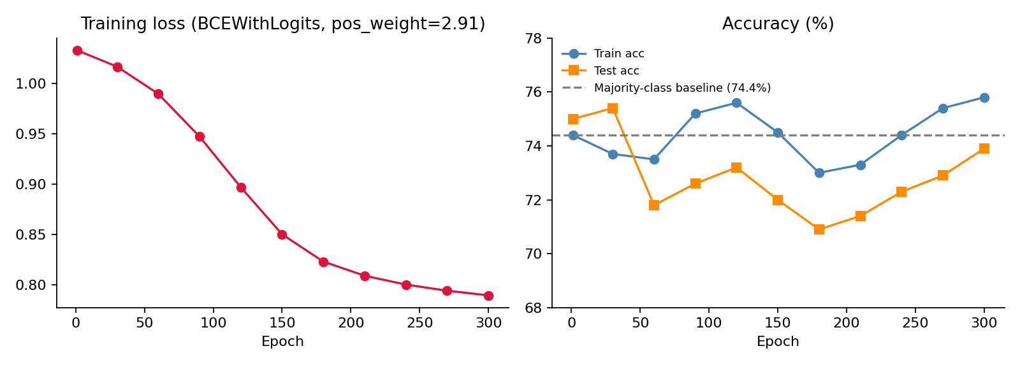
Figure 5. PyTorch training loss and accuracy at the logged epochs, with the majority-class baseline.
Loss decreased steadily from 1.03 to 0.79, but accuracy stayed between 71% and 76%, close to the 74.4% you would get by always predicting "no churn". The model is still improving at epoch 300, so more epochs or a larger learning rate may help. Because the loss up-weights churners, accuracy is also not the right yardstick; precision, recall or AUC on the churn class would be more informative.

4. Observations and recommendations

Notebook 1: fraud detection
- The zDNN check does not prove acceleration. The "accelerated ops" list is hard-coded print statements, and TensorFlow reports only a plain CPU device. The check shows the plugin and library are installed, not that NNPA executed the LSTM. To confirm, compare timings with the plugin disabled or use zDNN/NNPA profiling output.
- "Quick test" uses validation data. The sample file is built from validate_indices, so the quick-test numbers are validation results, not test results.
- Not all test rows are scored. The generator drops the last partial batch: 24 x 2,000 = 48,000 of 49,101 test rows (and the quick test reads 20 x 2,000 = 40,000). The Keras "ran out of data" warning is harmless here.
- Pre-processing is fitted on all data. The mapper is fit on the entire dataset, including test rows. This is mostly vocabulary and scaling, but a stricter setup would fit on training rows only.
- Precision is the weak point. With about 0.67 precision at 0.5 threshold, consider tuning the threshold on validation data, and report precision-recall AUC. The 2,000-row benchmark contains only 3 frauds, so its 0.43 precision is not statistically meaningful.
- The f1() helper is defined but never used.

Notebook 2: client retention
- Very small modelling set. The Random Forest is trained on about 90 clients and scored on about 22, with no accuracy, precision, recall or AUC reported. Its churn probabilities are coarse (0.08, 0.12, 0.44...).
- Scaling inconsistency. make_feature_space fits a new StandardScaler on whatever data it is given, so the test set is scaled with its own statistics instead of the training scaler. Save and reuse the training scaler (or put it in the pipeline).
- Possible identifier leakage. RECORD_ID is kept as a feature. It is an identifier, and may encode ordering that correlates with churn.
- Naming. The PMML file is called customer_churn_decision_tree_model but holds a Random Forest. The class "LogisticRegressionModel" is actually a three-layer neural network.
- Two different datasets. Sections 3.3 and 3.4 use 112 joined clients, while Section 3.5 uses all 6,001 clients with different features, so their results are not directly comparable.
- Weak neural-network result. Test accuracy of 73.9% matches the baseline. Try more epochs, additional features such as the transaction aggregates, and class-aware metrics.

